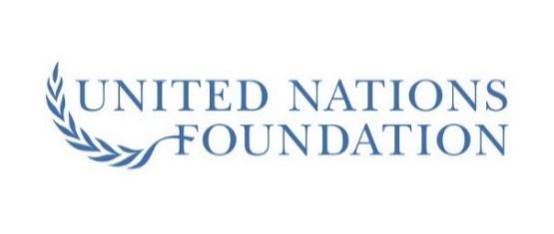

**IFAA calls for greater investment in immunisation this World Immunisation Week.**

This World Immunisation Week, Immunisation for All Ages (IFAA) supports the World Health Organization’s (WHO) statement that, “**at all ages, vaccines save lives and keep us safe”**[1]

and calls upon professional, patient and advocacy organisations, together with all levels of government to increase their investment in prevention policy that supports immunisation at all stages of life.

Vaccination is one of the most successful public health measures of modern times. In the current context of COVID-19, effective vaccination and protection of vulnerable groups is more important than ever. Maximising uptake of existing vaccines for respiratory diseases helps to mitigate the annual burden of disease (increased mortality and morbidity and healthcare costs) from flu and pneumococcal pneumonia, particularly in populations at greater risk of infection such as those who are older and those with chronic diseases.

Increasing national flu and pneumococcal uptake rates can also help healthcare systems to maximise the availability of healthcare resources to address the impact of COVID-19 on local populations, families and individuals.

Dr Jane Barratt, from The International Federation on Ageing, said: “It is vital that the value of vaccination at every milestone throughout life is achieved and no-one is left behind.”

This includes:

* Prioritising vaccination targets throughout life as a key pillar of expanded prevention strategies and a central component of universal health coverage.
* Removing barriers to uptake by improving vaccination pathways that include greater emphasis on continuous professional education and healthcare professionals qualified to administer vaccines.
* Reducing inequalities in the timely, appropriate and affordable access to immunisation throughout life, and most importantly to the most marginalised vulnerable populations.

The draft WHO *Immunisation Agenda 2030* calls on governments to expand, where appropriate, immunisation services beyond infancy to include the whole life course guided by evidence on the burden of disease, the value of vaccines, vaccines’ impact on reducing morbidity and mortality throughout the life course.[2]

**About IFAA**

Immunisation for All Ages is funded by Pfizer.

1. WHO (2020), World Immunization Week 2020. <https://www.who.int/news-room/campaigns/world-immunization-week/world-immunization-week-2020/key-messages>. Last accessed. March 2020
2. WHO (2019), Immunisation Agenda 2030: A Global Strategy to Leave No One Behind. Available at: <https://www.who.int/immunization/sage/meetings/2019/october/2_ia2030_SAGE_submission.pdf?ua=1>. Last accessed: March 2020.