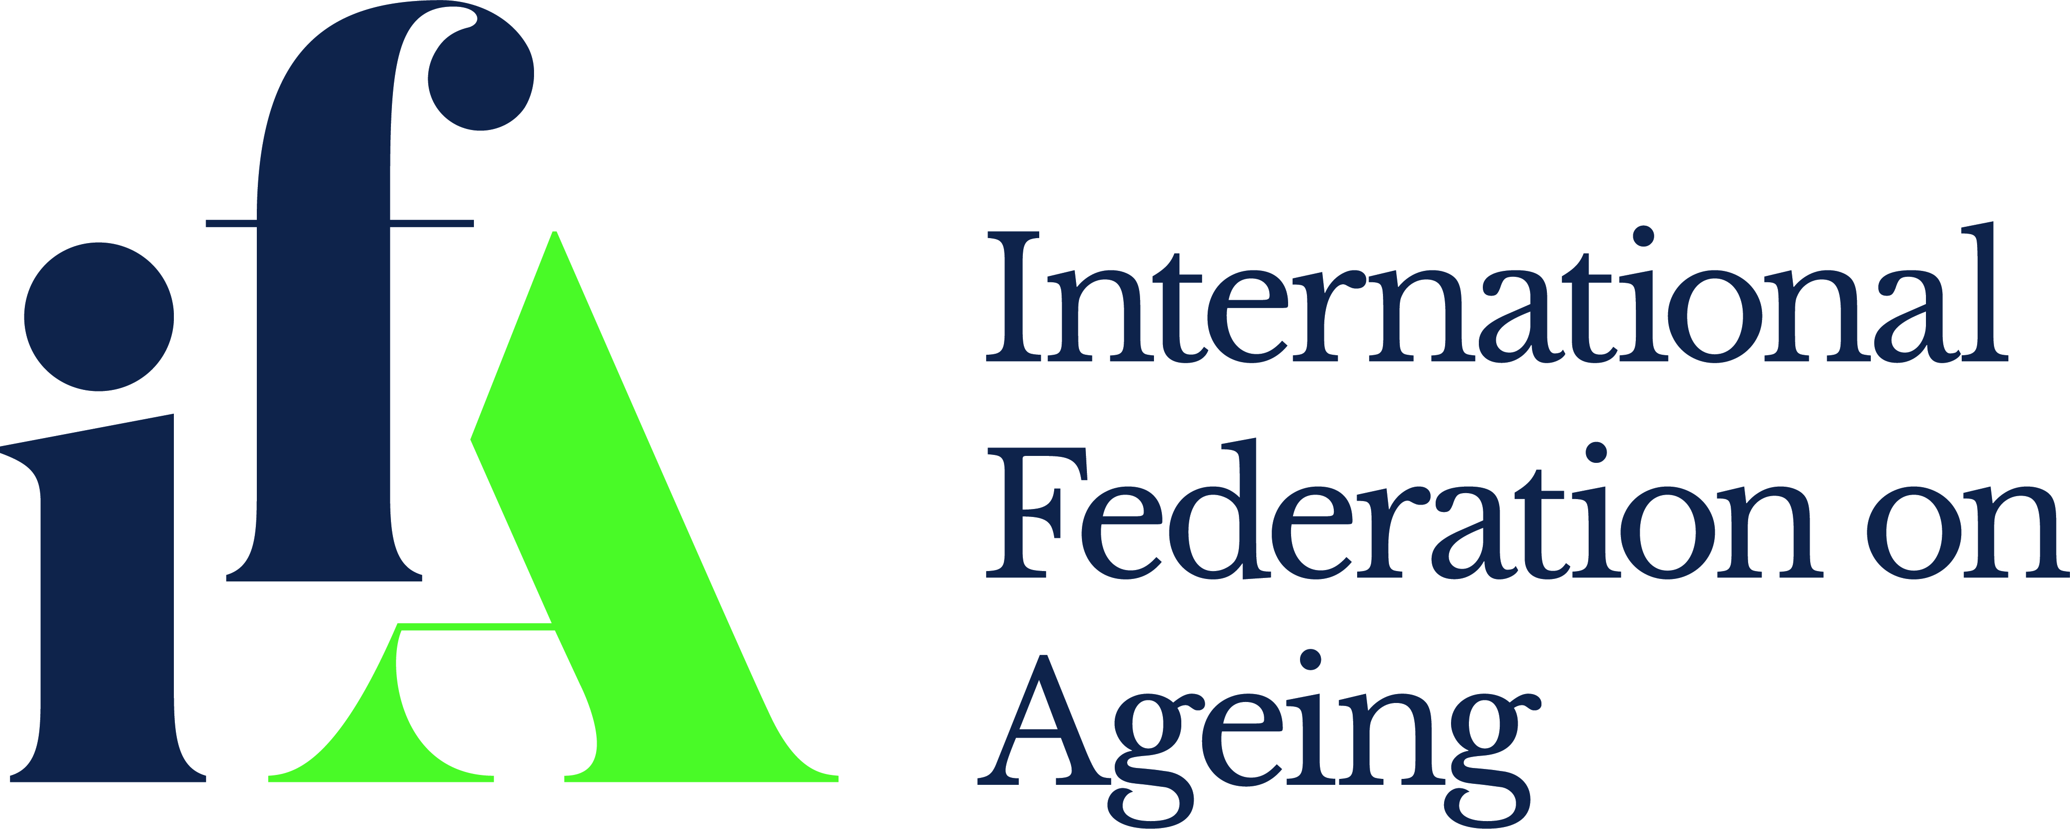

IFA Strategic Plan
2019 - 2021

Table of Contents
Our Identity 2
Our Vision 2
Our Mission 2
Our Commitment, Priorities and Goals 2
About the IFA 3
Context 3
Our history 3
Pillars of the Strategic Plan 4
Human Rights Approach 4
The UN Sustainable Development Agenda 4
WHO Global Strategy and Action Plan 5
UN-WHO-IFA Linkages 6
IFA Strategic Visual 7
Appendix 1 8
IFA Related UN Sustainable Development Goals 8
Appendix 2 10
IFA related Strategic Objectives of the WHO GSAP 10
Appendix 3 11
Intersection between WHO GSAP and the UN SDGs 11

International Federation on Ageing
“IFA Strategic Plan 2015-2020”

Our Identity

The International Federation on Ageing (IFA) is an international non-governmental organization (NGO) with a membership base comprising government, NGOs, industry, academia and individuals in over 70 countries.
The IFA has general consultative status at the United Nations (UN) and its agencies and is in formal relations with the World Health Organization (WHO).
The IFA is a voice is alongside and on behalf of older adults globally

Our Vision
A world of healthy older people whose rights and choices are both protected and respected

Our Mission
To be the global point of connection, engagement and networks of experts and expertise to influence and shape age-related policy

Our Commitment, Priorities and Goals
In line with our vision and mission for every older person to experience life in all its fullness, and in line with the call to help influence the UN Agenda 2030 and the WHO Global Strategy and Action Plan in 2019-2020 there is alignment across IFAs commitment, priorities and operational goals.
Our Commitment
LEADERSHIP TO IMPROVE POLICY | LEAVE NO ONE BEHIND | CHANGE LIVES BY REDUCING EQUITY | INVEST IN PARTNERSHIPS | SAFEGUARD HUMAN RIGHTS

Our Priorities
Fostering healthy ageing | Developing systems for long-term care | Creating age-friendly environments | Decent work for older people | Protecting the rights of older people

Our Operational Goals
Credible source of information and evidence
Innovator of platforms that connect and engage influencers
Influential advocate on ageing matters
Capacity builder across disciplines and sectors
Financially thriving and economically secure organization

About the IFA

Context
Demographic change, its consequences and direct relationship to the lives of older people are at the heart of the work of the International Federation on Ageing. Never has there been such a time as now to take action through offering a menu of concrete steps adapted for use in countries at all levels of economic development.
In 2017, the global population surpassed 7.6 billion. It is expected to reach 8.6 billion in 2030, 9.8 billion in 2050 and 11.2 billion in 2100.
The number of older persons in the world is projected to be 1.4 billion in 2030 and 2.1 billion in 2050. It could rise to 3.1 billion by 2100. Globally, the number of persons aged 80 years of age or over is projected to triple by 2050, from 137 million in 2017 to 425 million in 2050.
The implications and management of rapid population growth, as well as specific population-related themes are central to development efforts. For the first time in history, most people can expect to live beyond 60 years of age; and the consequences for health, health systems, their workforce and budgets are profound.

Our history
The International Federation on Ageing (IFA) is an international non-governmental organization with a membership base comprising government, non-governmental organizations (NGOs), academics, industry, and individuals in more than 70 countries. The IFA began operations in 1973, at a time when the social and economic impact of population ageing was only beginning to be understood by governments around the world.
The first time that NGOs took a role in formal United Nations (UN) deliberations was through the Economic and Social Council (ECOSOC) in 1946. Article 71 of the UN Charter opened the door for suitable arrangements for consultation with NGOs. This relationship with ECOSOC is governed today by ECOSOC resolution 1996/31. International, regional and national NGOs, non-profit public or voluntary organizations are eligible to obtain consultative status. There are three categories of status: general, special and roster consultative status.
The IFA has general consultative status at the United Nations and its agencies and is in formal relations with the World Health Organization. The IFA has been involved in drafting key initiatives such as the UN Principles for Older Persons, actively advocating for older people to be recognized in the Sustainable Development Goals (SDGs) and maintaining a strong voice in the dialogue on how to best protect the rights of older people globally.
The IFAs vision “a world of healthy older people whose rights and choices are both protected and respected” is aspired through the primary goal to be the global point of connection, engagement and networks of experts and expertise to influence and shape age-related policy
Key historical IFA initiatives include:
- The Declaration of the Rights and Responsibilities of Older Persons was first published in 1990 and thereafter adopted by the United Nations General Assembly in 1991 as the United Nations Principles for Older People
- In Montreal in 1999, the IFA’s Fourth Global Conference brought together Ministers responsible for ageing issues from 61 countries. This successful meeting resulted in the production of The Montreal Declaration on the Rights and Duties of Older People

Pillars of the Strategic Plan

The IFA Strategic Plan is grounded in a rights-based approach, underpinned by the United Principles for Older People and aligned with the UN Sustainable Development Agenda and WHO Global Strategy and Action Plan.
The United Nations and World Health Organization provides a critical source of alignment and direction to the IFA in the identification of priorities, development and implementation of work plan. In 2015 the United Nations (UN) and World Health Organization (WHO) launched interconnecting agendas that have the potential to positively transform our world and provide a sound framework for the IFAs Strategic Plan 2019 – 2021.

Human Rights Approach
Longer lives bring great opportunities, including the possibility of rethinking growing older in an ever-changing environment. The rights of older people being human rights is the overarching covenant of the work of the International Federation on Ageing. For more than 10 decades UN agencies, member states and civil society has been striving to understand how to formally protect the rights of older people globally.
In 2002 the UN Madrid International Plan of Action on Ageing represented the first time governments agreed to link questions of ageing to other frameworks for social and economic development and human rights, most notably those agreed at the United Nations conferences and summits of the past decade.
In 2010 the UN Open-Ended Working Group on Ageing (UN OEWG) was established by the General Assembly by resolution 65/182. Its mandate is to consider the existing international framework of the human rights of older persons and identify possible gaps and how best to address them, including by considering, as appropriate, the feasibility of further instruments and measures.
In 2019, the UN OEWG will convene for the 10th year to focus on two areas: social protection and social security including social protection floors and education, training, lifelong learning; and capacity-building in the context of older persons.
The IFA through its representation and leadership at the UN NGO Committee on Ageing in New York, Geneva and Vienna; UN and WHO sub committees in human rights; and membership of Global Alliance for the Rights of Older People (GAROP) directly works to improve the rights of older people. The IFA commits to using a human rights lens across its governance, management, operations and programs.

The UN Sustainable Development Agenda
The UN Sustainable Development Agenda and its 17 Sustainable Development Goals (SDGs) makes it clear that a healthy life and the right to health does not start or end at a specific age. The SDGs build on the success of the Millennium Development Goals (MDGs), and are unique in the call for action by all countries to promote prosperity. They recognize that ending poverty is linked with strategies that build economic growth and address social needs including education, health, social protection and employment.
The SGDs are applicable to all ages, including the later years of life; and if they are to be achieved rapid population ageing that is occurring in almost every country must be central to the conversations and actions.
Today older people experience poor health trajectories, yet, the health issues they confront are often associated with chronic conditions that can be prevented or delayed. For older adults with significant declines in capacity, supportive environments and integrated care systems can ensure that they live lives of dignity and continued personal growth.

WHO Global Strategy and Action Plan
A longer life in poor health is not a reward but rather a burden for the individual, as well often their family and society. So, the great opportunities with longer lives is in maintaining good health into older age.
The WHO Global Strategy and Action Plan on ageing and health provides a political mandate for action that is required to ensure that everyone has the opportunity to experience both a long and healthy life. The strategy is grounded in the concept of healthy ageing as being much more than the absence of disease but rather the functional ability of older people to be and to do what they value.
The strategy sets forth five objectives to achieve this. These include a call for countries to commit to action; to develop age-friendly environments; to align health systems to the needs of the older populations; and to develop sustainable and equitable systems of long-term care. Finally, it emphasizes the importance of improved data, measurement, and research, and involving older people in all decisions that concern them.
By acting on the strategy, countries will also contribute to implementing the 2030 Agenda for Sustainable Development, which pledges that no one will be left behind and that every human being, regardless of their age, will have the opportunity to fulfil their potential in dignity and equality.
Fundamental to aspiring to be a global influencer the IFA must not only inform and recognize the directions of the World Health Organization and the United Nations (e.g. the UN Sustainability Goals) but be prepared to stand independently behind such reports that through strategic and collective action have the potential to change the lives of older people globally.

UN-WHO-IFA Linkages
The IFA in its formal working relationship at the UN Economic and Social Council and the WHO Department of Ageing and Health agrees on a specific workplan that the organization reports on annually, as well as at the end of four- and three-year period respectfully.
The broad overview illustrated in the chart below provides a clear picture of the relationship of the current IFA Priorities to those WHO and UN SDGs.
 | IFA Priorities | Links to WHO Priorities and UN SDGs | Cross Cutting Themes  5. IFA Priority  Combating Ageism
1. | Fostering healthy ageing | WHO Priorities  WHO 1: Commitment to action on healthy ageing in every country.  WHO 3: Aligning health systems to the needs of older populations.  6. IFA Priority  Applied Technology  UN SDGs  SDG 1: Good health and well being.
2. | Long term care | WHO Priorities  SDG 5.  Gender  Equality  WHO 4 Developing sustainable and equitable systems for long-term care.
3. | Age-friendly  environments | WHO Priorities  SDG 10.  Reduced Inequalities  WHO 2 - Developing age-friendly environments.  UN SDGs  SDG 1: Good health and well being.  SDG 17.  Partnerships For The Goals
4. | Decent work for all | UN SDGs  SDG 11: Sustainable cities and communities.

IFA Strategic Overview
WHO Global Strategy and
Action Plan

IFA 1:
Fostering Healthy
Ageing

UN Agenda 2030
UN OEWG

IFA 6:
Applied Technology

Our Vision
A world of healthy older people whose rights and choices are both protected and respected
Goal 2:
Create innovative platforms that connect, engage and inform
Goal 1:
Be a credible source
of information and
evidence

IFA 5:
Combating Ageism

Goal 3:
Advance as an
influential advocate
on ageing matters
Goal 4:
Be a capacity builder across disciplines and sectors
IFA 4:
Decent Work
For All

Priority 3:
Age-friendly
Environments
Goal 5:
Be a financially thriving and economically secure
organization
IFA 2:
Long Term Care

Appendix 1

IFA Related UN Sustainable Development Goals
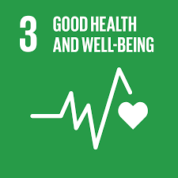 | Ensuring healthy lives and promoting the well-being at all ages is essential to sustainable development. Significant strides have been made in increasing life expectancy and reducing premature deaths due to non-communicable diseases.  Greater efforts are needed to fully eradicate a wide range of diseases and address many different persistent and emerging health issues. By focusing on providing more efficient funding of health systems, improved sanitation and hygiene, increased access to physicians’ significant progress can be made in helping to save the lives of millions.
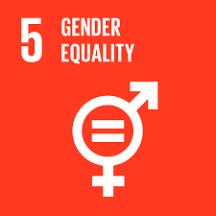 | Gender equality is not only a fundamental human right, but a necessary foundation for a peaceful, prosperous and sustainable world. While there has been progress towards gender equality many continue to suffer discrimination and violence in every part of the world.  Providing equal access to education, health care, decent work, and representation in political and economic decision-making processes will fuel sustainable economies and benefit societies and humanity at large.
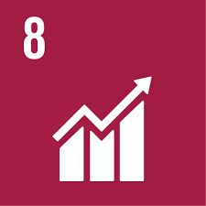 | Roughly half the world’s population still lives on the equivalent of about US$2 a day with global unemployment rates of 5.7%. The lack of decent work opportunities, insufficient investments and under-consumption lead to an erosion of the basic social contract underlying democratic societies: that all must share in progress.  Sustainable economic growth will require societies to create the conditions that allow people to have quality jobs that stimulate the economy while not harming the environment. Job opportunities and decent working conditions are also required for the whole working age population.
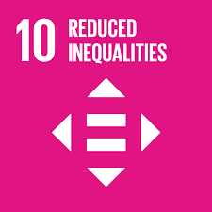 | Despite significant strides globally inequality persists, and large disparities remain regarding access to health and education services and other assets.  To reduce inequality, policies should be universal in principle, paying attention to the needs of disadvantaged and marginalized populations.
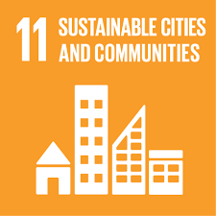 | Cities are hubs for ideas, commerce, culture, science, productivity, social development and much more. At their best, cities have enabled people to advance socially and economically.  Many challenges exist to maintaining cities in a way that continues to create jobs and prosperity without straining land and resources. Common urban challenges include congestion, lack of funds to provide basic services, a shortage of adequate housing, declining infrastructure and rising air pollution within cities.
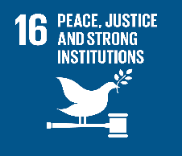 | The threats of international homicide, violence against children, human trafficking and sexual violence are important to address to promote peaceful and inclusive societies for sustainable development. They pave the way for the provision of access to justice for all and for building effective, accountable institutions at all levels.  To tackle these challenges and build a more peaceful, inclusive societies, there needs to be more efficient and transparent regulations put in place and comprehensive, realistic government budgets.
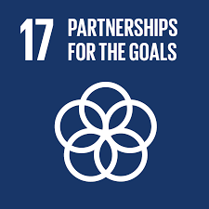 | Partnerships between governments, the private sector and civil society built upon principles and values, a shared vision, and shared goals that place people at the centre, are needed at the global, regional, national and local level.  Urgent action is needed to mobilize, redirect and unlock the transformative power of knowledge and resources to deliver on sustainable development objectives.

Appendix 2

IFA related Strategic Objectives of the WHO GSAP
1: Commitment to action on healthy ageing in every country
  - Establish national frameworks for action on healthy ageing
  - Strengthen national capacities to formulate evidence-based policy
  - Combat ageism and transform understanding of ageing and health
2: Developing age-friendly environments
2.1 Foster older people’s autonomy
2.2 Enable older people’s engagement
2.3 Promote multisectoral action
3: Aligning health systems to the needs of older populations
3.1 Orient health systems around intrinsic capacity and functional ability
3.2 Develop and ensure affordable access to quality older person-centred and integrated clinical care
3.3 Ensure a sustainable and appropriately trained, deployed and managed
health workforce
4: Developing sustainable and equitable systems for long-term care
4.1 Establish and continually improve a sustainable and equitable long-term care system
4.2 Build workforce capacity and support caregivers
4.3 Ensure the quality of person-centred and integrated long-term care
5: Improving measurement, monitoring and research
5.1 Agree on ways to measure, analyse, describe and monitor healthy ageing
5.2 Strengthen research capacities and incentives for innovation
5.3 Research and synthesize evidence on Healthy Ageing

Appendix 3

Intersection between WHO GSAP and the UN SDGs
The WHO global strategy and action plan on ageing and health also responds to the SDGs, and from an ageing perspective believes it to be relevant to 15 of the 17 Goals;
Goal 1 | End poverty in all its forms everywhere – for all men and women;
Goal 2 | End hunger, achieve food security and improved nutrition
Goal 3 | Ensure healthy lives and promote well-being for all at all ages through universal health coverage including financial risk protection
Goal 4 | Ensure inclusive and equitable quality education and promote lifelong learning opportunities for all
Goal 5 | Achieve gender equality and empower all women and girls
Goal 8 | Promote sustained, inclusive and sustainable economic growth, full and productive employment and decent work for all
Goal 10 | Reduce inequality within and among countries, by promoting the social, political and economic inclusion of all, irrespective of age
Goal 11 | Make cities and human settlements inclusive, safe, resilient and sustainable by providing universal access to safe, inclusive and accessible green and public spaces, in particular for older persons
Goal 16 | Promote peaceful and inclusive societies for sustainable development, provide access to justice for all and build effective, accountable and inclusive institutions at all levels

